Modeling Doxy PEP coverage

Mathematical model

Coverage formulation
Let:
- $C_{t}$ = fraction of population currently on treatment (coverage)
- $u$ = fraction of population starting treatment per time step (uptake)
- $λ$ = discontinuiation rate

Duration on treatment is exponentially distributed:
$$P(\text{dur}>t)=e^{-λt}$$
- Persistence after 1 year:
$$P=P(\text{dur}>1)=e^{-λ}$$

Population approximation:
$$Ct+1​=u+(1-λ)Ct$$

If we solve this for the steady-state (C*):
$$C^{*}=\frac{u}{λ}$$
But this only works if $λ>0$

How do we get to C=u/1+$λ$ ?

Assuming the math works:
Let P stand for persistence. Then $λ=-log⁡(P)$

And follows:
$$C^{*}=\frac{u}{1+λ}=\frac{u}{1-\log\left(P\right)}$$
Then
$U=C×(1-\log\left(P\right))$ (1)

Approximating DoxyPep based on HIV PrEP
we can estimate Doxy uptake from PrEP uptake as follow:

$${U_{Doxy}=U}_{PrEP}×{n.elig}_{PrEP}×Q$$

Where ${n.elig}_{PrEP}$ is the population eligible for PrEP and Q is the fraction of this population that start Doxy [0-1].

Using equation 1:
$$C_{Doxy}×\left(1-\log\left(P_{Doxy}\right)\right)=U_{PrEP}×{n.elig}_{PrEP}×Q$$
or
$$C_{Doxy}=\frac{U_{PrEP}×{n.elig}_{PrEP}×Q}{(1-\log\left(P_{Doxy}\right))}$$

We have data on Uptake of PrEP and number of people eligible for PrEP

- We need to estimate Doxy persistence and fraction of PrEP eligible population taking Doxy (Q) from the literature.

Data on Doxy-PEP Persistence (Adherence/Usage)

Persistence is measured as adherence in clinical studies or as "proportion of days covered" in health system analyses.

- Clinical Trials (Self-reported adherence):
  - Across several trials, self-reported adherence to doxy-PEP was high, averaging approximately 80%.
  - In the dPEP trial among cisgender women in Kenya, lack of efficacy was attributed to low adherence, with only 44% having detectable doxycycline levels in hair samples, versus 78% self-reporting coverage, highlighting the difference between reported and actual use in some contexts.
- Real-World Clinical Settings (Usage Patterns):
  - A Philadelphia study found that among 416 doxy-PEP recipients, most (54.3%) were categorized as having "medium usage" (dispensed at 26-74% of visits), while 21.2% had "low usage" (25% of visits) and 24.5% had "high usage" (75% of visits).
  - A Kaiser Permanente Northern California (KPNC) study using pharmacy data found the median number of fills per recipient was 2 (interquartile range, 1-3) over a median follow-up of 5.7 months. The median number of doses in possession per month was 6.5 (IQR, 4.3-10.6).
  - A national survey among MSM living with HIV in the US found that of those prescribed doxy-PEP, 22% had not taken it at all in the previous four weeks, while others reported varying frequency (38% monthly, 10% nearly daily).

Data on % of PrEP-Eligible Individuals Receiving Doxy-PEP (Uptake)

Uptake data is highly dependent on the clinic setting, population demographics, and geographic location.

- In a large integrated health system in California (KPNC), only 19.5% of 11,551 individuals already on HIV PrEP were dispensed doxy-PEP during the study period (Nov 2022 - Dec 2023).
- A study extension in a different clinic setting found a higher uptake rate: among 3081 PrEP clients offered doxy-PEP, 39% started it.
- A Philadelphia clinic reported that among 508 eligible men, 82% opted to receive doxy-PEP. This highlights potential differences between patient acceptance (opt-in) and actual dispensing rates in a larger health system.
- A US national survey found that only 20% of CDC-eligible participants were prescribed doxy-PEP.

Demographic Disparities in Uptake:
- Uptake rates in the California study were similar across most racial/ethnic groups but varied by gender identity (e.g., 39% of cisgender men vs. all 14 cisgender women offered it declining).
- Regional disparities exist, with lower uptake observed in the U.S. South, Midwest, and Mountain regions compared to the Pacific region.

- 2025 final results: Luetkemeyer, A. F., Donnell, D., Cohen, S. E., Dombrowski, J. C., Grabow, C., Haser, G., ... & Celum, C. (2025). Doxycycline to prevent bacterial sexually transmitted infections in the USA: final results from the DoxyPEP multicentre, open-label, randomised controlled trial and open-label extension. The Lancet Infectious Diseases.

https://www.thelancet.com/journals/laninf/article/PIIS1473-3099(25)00085-4/fulltext

- Sokoll, P. R., Migliavaca, C. B., Döring, S., Traub, U., Stark, K., & Sardeli, A. V. (2025). Efficacy of postexposure prophylaxis with doxycycline (Doxy-PEP) in reducing sexually transmitted infections: a systematic review and meta-analysis. Sexually Transmitted Infections, 101(1), 59-67.

https://sti.bmj.com/content/101/1/59.abstract

- Traeger, M. W., Leyden, W. A., Volk, J. E., Silverberg, M. J., Horberg, M. A., Davis, T. L., ... & Marcus, J. L. (2025). Doxycycline postexposure prophylaxis and bacterial sexually transmitted infections among individuals using HIV preexposure prophylaxis. JAMA internal medicine, 185(3), 273-281.

https://jamanetwork.com/journals/jamainternalmedicine/fullarticle/2828994

- Scott H, Roman J, Spinelli MA, et al. Doxycycline PEP: High uptake and significant decline in STIs after clinical implementation. CROI 2024 (Conference on Retroviruses and Opportunistic Infections), March 3-6, 2024, Denver. Abstract 126.

https://www.natap.org/2024/CROI/croi_36.htm#:~:text=Among%203081%20total%20PrEP%20clients,people%20opted%20to%20try%20DoxyPEP.

- Lewis, Felicia M. T., Anna B. Cope, Kelly Clark, Robbie Madera, Lenore Asbel, Daniel R. Newman, and Nicole L. Davis. 2025. “Doxycycline Postexposure Prophylaxis Is Effective and Highly Acceptable in an Urban Public Sexually Transmitted Disease Clinic: Philadelphia, 2019–2023.” Sexually Transmitted Diseases 52 (12): 734–38.

https://doi.org/10.1097/olq.0000000000002224.

- Traeger, M. W., Krakower, D. S., Mayer, K. H., Jenness, S. M., & Marcus, J. L. (2024). Use of doxycycline and other antibiotics as bacterial sexually transmitted infection prophylaxis in a US sample of primarily gay and bisexual men. Sexually Transmitted Diseases, 10-1097
https://journals.lww.com/stdjournal/fulltext/2024/12000/use_of_doxycycline_and_other_antibiotics_as.1.aspx

Modeling Uptake:

Study | Population Denominator | Uptake (%) | n
KPNC (health system) | HIV PrEP Dispensed  ( > 1 prescription) | 19.5% | 11,551 | retrospective cohort study of adults (aged ≥18 years) dispensed HIV preexposure prophylaxis (PrEP) at Kaiser Permanente Northern California during November 1, 2022, to December 31, 2023  data to compare HIV PrEP users dispensed and not dispensed doxyPEP and rates of bacterial STIs before and after starting doxyPEP | https://pubmed.ncbi.nlm.nih.gov/39761062/
San Francisco clinic | HIV PrEP Dispensed  ( > 1 prescription) | 39% | 3,081
National survey | CDC-eligible MSM | 21% | 903
 | On HIV PrEP (actively) | 25.1% | 383
 | Ever used HIV PrEP | 21.5% | 469
Philadelphia clinic | HIV PrEP eligible ( ≥2 clinic visits) | 82% | 508

Modeling Persistence/Duration:

From the KPNC Health System Paper

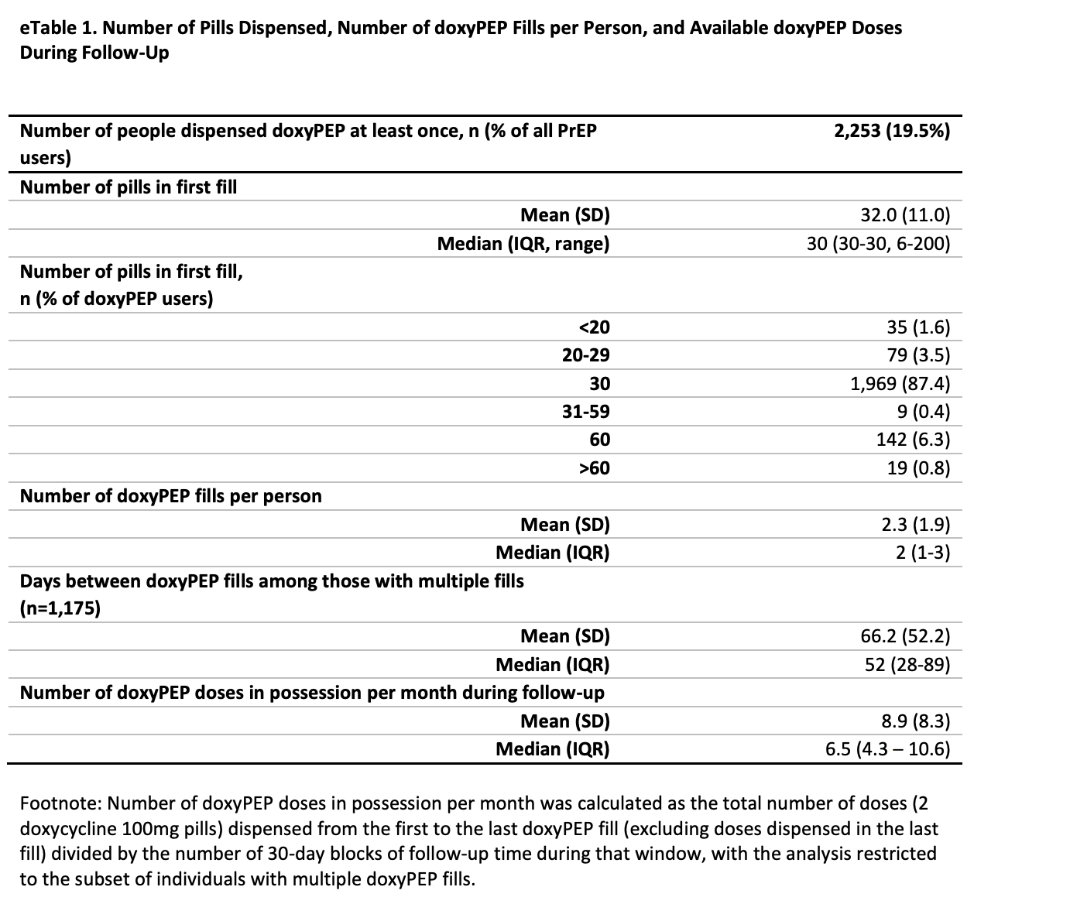

- Assume a fill every 66 days, on average
- Assume 2.3 fills per user
- The average time on doxy until running out:
Then:

Survival at time t:
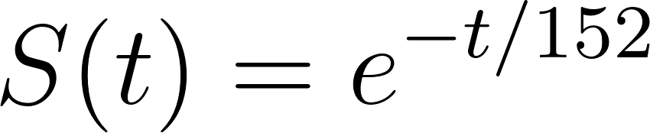

At 1 year = 365 days:

About 9% of the cohort would still be on doxyPEP at 1 year under this assumption.

Suppose 152 days is the average duration across all doxyPEP users,
and we treat non-refillers as having refills ≈ 0.
Then what does that imply for refillers, and what’s the 1-year % still covered?

We have N = 2253 doxyPEP users. Of these, 1175 received more than one fill and 1078 received only one fill. Therefore,

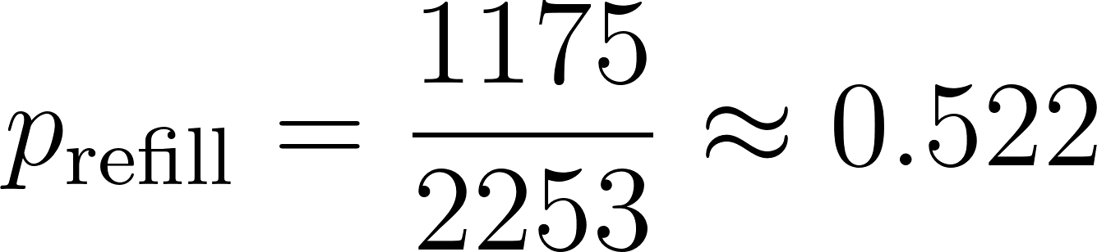
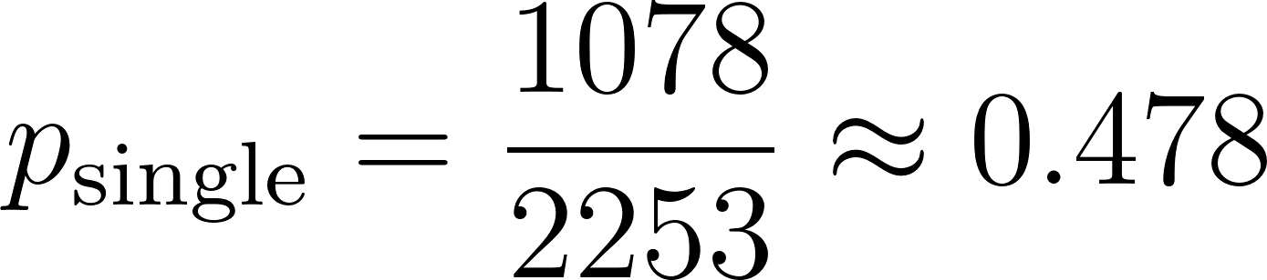

Then to find E[X_{refill}]:

Which results in:

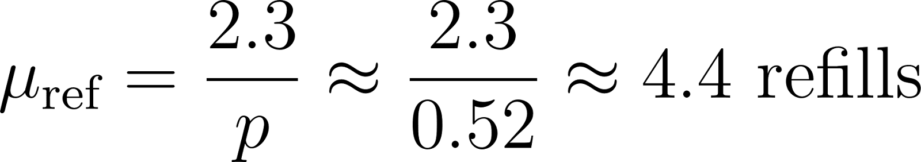

Then:

About 28% of the cohort would still be on doxyPEP at 1 year under this assumption.

